|  |
| --- |
| **National University of Computer and Emerging Sciences** |
| Lab Manual 3  “Introduction to SQL Retrieval, Set Operations, Joins” |
|  |
| Database Systems |
| Spring 2022 |

Department of Computer Science

FAST-NU, Lahore, Pakistan

**Table of Contents**

Objective 3

Task Distribution 3

1. SELECT-FROM-WHERE 4

a) Most Basic Select: 4

b) Retrieving certain Columns from Select 5

c) Retrieving certain Rows from Select- WHERE CLAUSE 5

d) Between condition 6

e) Like operator 6

f) Renaming Resulting Column 7

2. Set operations 7

3. Join Operation 9

a) Inner Join: 9

b) Left/Right/Full Outer Join 9

c) Cross Join 11

d) Joining More than two tables 11

Appendix 12

# Objective

The purpose of this lab activity is to familiarize you with the concept of SQL Set Operations and Joins.

# Task Distribution

|  |  |
| --- | --- |
| Total Time | 150 Minutes |
| Select From Where | 15 Minutes |
| Set Operations | 5 Minutes |
| Joins | 10 Minutes |
| Miscellaneous Functions | 10 Minutes |
| Exercise | 110 Minutes |

# SELECT-FROM-WHERE

Select from where is equivalent to projection and selection in Relational Algebra, it will give output in form of a table.

The most basic select statement includes Select and from clause, and it will retrieve all columns and rows from the table.

We will use the following schema and database for the examples. Script to create this schema is given in Lab4ExampleSchema.sql file

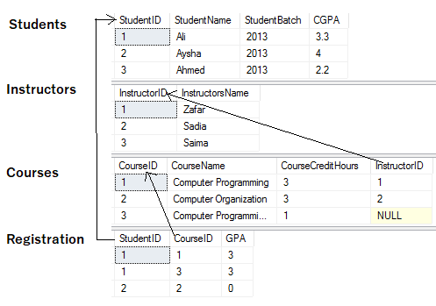

## Most Basic Select:

SELECT *

FROM <table Name>

* after select means that all columns will be retrieved

Try this



Results

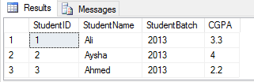

## Retrieving certain Columns from Select

To retrieve only certain columns give a comma separated list of those columns after Select keyword

SELECT ColumnX, ColumnY, ColumnZ

FROM <tableName>

Try this



Results

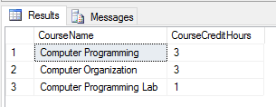

## Retrieving certain Rows from Select- WHERE CLAUSE

Like Selection in RA, rows are filter in SQL using WHERE clause, rows that fulfill where clause conditions will be projected in result. Where clause can put condition on original columns of tables mentioned on from clause, or derived columns.

SELECT *

FROM <table Name>

where <conditions>

Try this



Results

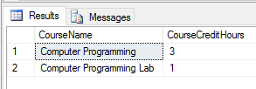

## Between condition

The BETWEEN operator selects values within a given range. The values can be numbers, text, or dates. (inclusive boundary values)

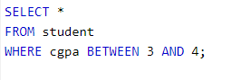

You can also check the range for date data types



## Like operator

The LIKE operator is used in a WHERE clause to search for a specified pattern in a column.

There are two wildcards used in conjunction with the LIKE operator:

* % - The percent sign represents zero, one, or multiple characters
* _ - The underscore represents a single character

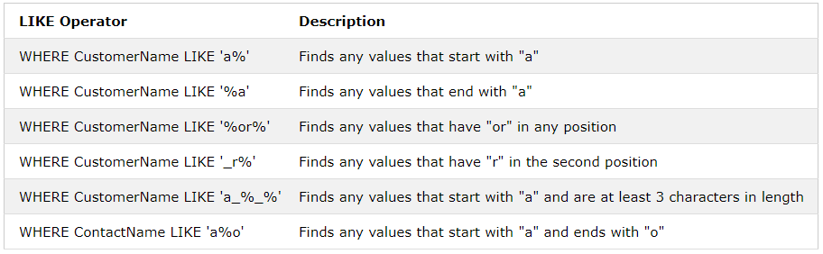

## Renaming Resulting Column

You can rename a column in result by using AS keyword also called Alias. The scope of this renaming is only to that select query, this is useful in joining where more than one table have same column names.

SELECT ColumnX as X , ColumnY as Y, ColumnZ

FROM <tableName> as Table1

Try this



Results

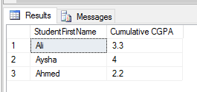

# Set operations

Result of two (or more) select queries can be combined using Set operations such as UNION, INTESECT, EXCEPT.

Syntax

Select ColumnX, ColumnY

From Table1

Union/Intersect/Except

Select ColumnA, ColumnB

From Table2

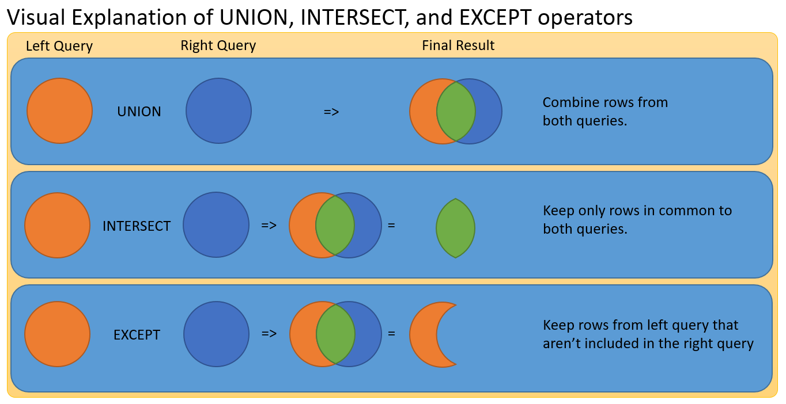

NOTE: The output of first select query should have same number and type of column as of second select query.

**Try this- error to look out for in set operations**

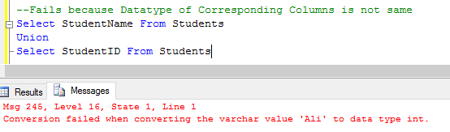

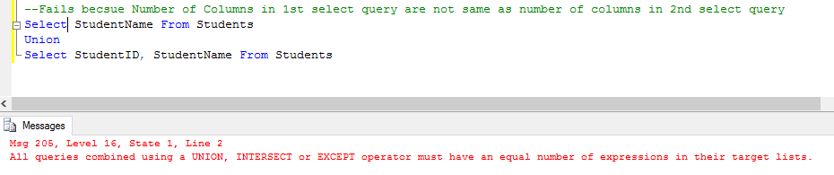

# Join Operation

We will use the following tables in examples

## Inner Join:

Returns only those rows that match in both tables.

SELECT *

FROM <table1> inner join <table2>

ON <Joining Condition>

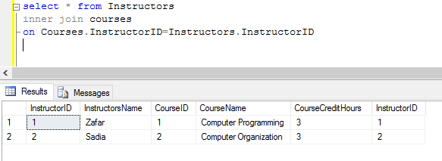

## Left/Right/Full Outer Join

Left Join: Returns all the rows of Left table with corresponding row or null row of right table

Right Join: Returns all the rows of Right table with corresponding row or null row of Left table

Full Join: Union of Left and Right Outer join

SELECT * FROM <table1> Left/Right/Full join <table2> ON <Joining Condition>

Try these

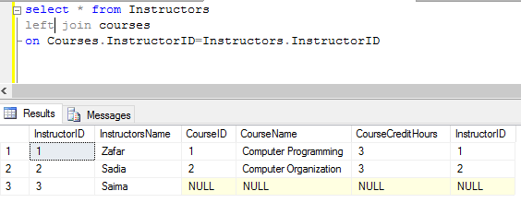

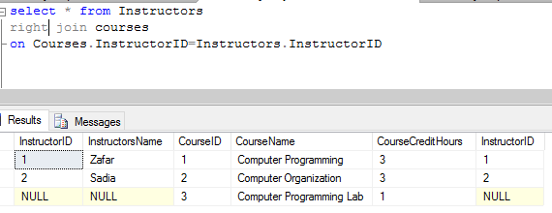

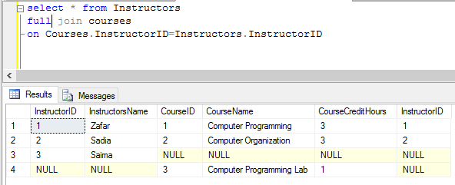

## Cross Join

It’s a cross product of two tables, no ON condition is required here

SELECT * FROM <table1> cross Join <table2>

Try this

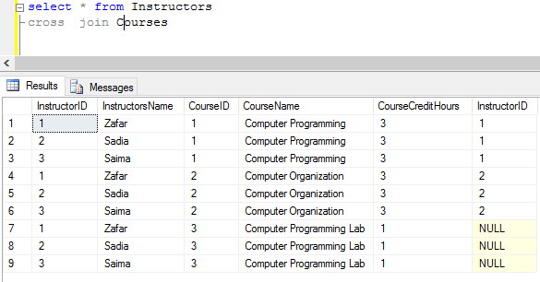

## Joining More than two tables

SELECT *

FROM <table1>

Left/Right/Full/Inner join <table2> ON <Joining Condition>

Left/Right/Full/Inner join <table3> ON <Joining Condition>

Left/Right/Full/Inner join <table4> ON <Joining Condition>

Try this

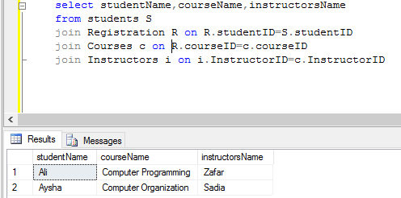

# Appendix

Some Useful clause

Distinct

--% eliminates duplicated.

Select Distinct Departments from students

Like

--% for Any string of zero or more characters.

Select * from students where studentName like '%ed%'

-- _ for Any single character.

Select * from students where studentName like 'Ahm_d'

--[] for Any single character within the specified range ([a-f]) or set ([abcdef]).

select * From Students where studentName like 'Ahm[ae]d'

--[^] for Any single character not within the specified range ([a-f]) or set ([abcdef]).

select * From Students where studentName like 'Ahm[^a]d'

is null/ is not null

select * from Course where InstructorID is null

select * from Course where InstructorID is not null

between

select * From Students where studentId between 1 and 10

select * From Orders where orderDate between '2-2-2001' and '2-2-2010'

select *, year(orderDate) as Year From Orders where year(orderDate) between 2001 and 2010

Some usefull functions

isNull(col,value) – replces the null entry with value

CAST ( expression AS data_type )

CONVERT ( data_type, expression)

DATE FUNCTIONS

DATEPART(datepart, date) --returns the datepart of date

Year(date)-- returns the Year of date

Month(date) --returns month of date

Day(date) --returns Day from date

DATEDIFF ( datepart , startdate , enddate ) –-returns the difference in start and end date in datepart (eg year,days ,months)

STRING FUNCTIONS

UPPER(String)

LOWER(String

LEFT(String,7) -- returns left 7 Characters

RIGHT(String,7)

LEN(String)

LTRIM (String) -- Trim the left end of string

RTRIM(String)

SUBSTRING (String, 8, 7)

CHARINDEX ('demo', String) –will return the starting index of ‘demo’ in String

REPLACE (String,'s','$') REVERSE (String)